Name: Obinna Williams
Student ID: VEPH/20B/DA183
TASK 16Biv

TECHNICAL REPORT FOR ZENFIT WELLNESS REPORT FOR THE YEAR 2024

Outline
- Introduction
- Story of Data
- Data Splitting and Pre-processing
- Pre-Analysis
- In-Analysis
- Post-Analysis and Insights
- Data Visualization & Charts
- Recommendations and Observations
- Conclusion
- References & Appendices

INTRODUCTION
Objective of the Project
The analyses focus on identifying key wellness trends among different demographics and occupational groups. The study aims to highlight factors influencing stress levels, sleep quality, and physical activity, providing actionable insights for improving workplace and personal wellness.

Problem Being Addressed
This analysis seeks to answer critical wellness-related questions, such as:
- Which occupations experience the highest stress levels?
- How does sleep duration vary across different professions?
- What is the relationship between BMI, physical activity, and daily step count?
- How do blood pressure levels correlate with sleep quality?

Key Datasets and Methodologies
- Datasets Used:
- Occupational stress and sleep duration data.
- Physical activity levels by age and BMI.
- Blood pressure and its correlation with sleep quality.

Methodologies Employed:
- Pivot tables & Pivot charts.
- Bar charts & Pie charts were utilized for visualisation.
- Filters & Slicers to segment data for detailed insights.

STORY OF THE DATA
Data source
This dataset is sourced from Kaggle.com

Data Collection Process
The data collection process is by web scraping.

Data Structure
The dataset is organized in a tabular format, where:
- Each row represents individual records.
- Each column captures different attributes such as occupation, stress level, sleep duration, BMI category, blood pressure readings, and physical activity levels.

Important features and their significance
- Occupation: Helps identify high stress professions.
- Stress level: measures employee well-being and job strain.
- Sleep Duration: assess the impact of rest on wellness.
- BMI Category: determines health risks related to weight.
- Physical Activity Level: Highlights engagement in movement and exercise.
- Blood Pressure: evaluates cardiovascular health in relation to sleep and stress.

DATA SPLITTING AND PREPROCESSING
Data Cleaning
To ensure accuracy and consistency, the following steps were taken to clean the data:
- Removing Duplicates: Identified and eliminated duplicate entries using Excel’s built in functions to prevent double counting of patient records.
- Handling Formatting Issues: Standardized data formats and ensured numerical values were correctly formatted.

Handling Missing Values
- There were no missing values.

Data Splitting
Independent Variables: These are factors that influence sales but don’t rely on other data points,
- Gender
- Age
- Occupation
- Physical activity level
- BMI Category
- Daily steps.

Dependent Variables: These are factors that change based on independent variables,
- Sleep duration.
- Quality of sleep.
- Blood pressure
- Heart rate.
- Sleep disorder.
- Stress level

Industry Context
- Industry Type: A Health and wellness industry.
- Relevance: It provides insights into employee well-being and how different factors contribute to stress, sleep quality, and physical activity.

Key Stakeholders
- Government health agencies and Healthcare professionals.

Value to the Industry
- Improve workplace wellness initiatives by identifying high-risk professions.

PRE-ANALYSIS
Potential Analysis
1. How does sleep duration differ across different age groups?
2. Does physical activity level influence stress level?
3. What is the distribution of sleep disorders across gender?
4. Is there a relationship between daily steps and heart rate?
5. How does occupation impact quality of sleep?
6. Are individuals in certain BMI Categories more likely to have a sleep disorder.
7. Does blood pressure relates with stress level?
8. How does Age influence the likelihood of having a sleep disorder?
9. What is the relationship between sleep duration and daily steps?
10. Does gender affect the distribution of stress levels?
Potential Insights
1. Age related physiological changes may lead to shorter sleep durations.
2. Higher physical activity levels relates with lower stress, reinforcing the role of movement in mental well-being.
3. Hormonal fluctuations, stress and lifestyle factors might contribute to a higher-level prevalence of insomnia among females.
4. Professionals in demanding jobs like law and healthcare, may report worse sleep quality to irregular schedules.
5. Chronic stress might elevate blood pressure, increasing cardiovascular risks.
6. Factors like medication, chronic conditions, and lifestyle changes can contribute to sleep issues in older populations.
7. Individuals sleeping more than average might engage in fewer physical activities, which may affect fitness levels.
8. Women might report higher stress due to a mix of biological and societal influences.

IN-ANALYSIS
Unconfirmed insights:
1. The chart shows a peak sleep duration sum around Nurses (515.6 hours) and a sharp dip around managers (6.9 hours).
2. Males have a higher total stress level (1,149) compared to females (865).
3. Individuals with a normal BMI category have the highest quality of sleep (1,494), followed by overweight individuals (1,021).
4. Age group of 41-50 has the highest stress level of 797 and age group of 21-30 have the lowest stress level of 219.
5. Doctors and nurses have the highest stress level at 478 and 405, while teachers have the lowest at 181.
6. Blood pressure range 130/85 have the highest quality of sleep at 717, while blood pressure range 125/82 has the lowest quality of sleep at 28.
7. 41-50 age group has the highest physical activity level at 8,847, and 21-30 age group at 1,747.
8. Normal BMI has the highest daily steps at 1,343,00, while the obese category has the lowest at 33,500.

Preliminary Recommendations:
1. The healthcare sector (Nurses, Doctors) shows a mix of high and low sleep durations, further analysis could explore whether nurses with fixed shifts sleep more than those with rotating schedules.
2. Males may be experiencing higher stress due to workplace pressure, responsibilities, or societal expectations.
3. Excess weight may contribute to sleep disturbances, possibly due to conditions like sleep aponia.
4. The 21-30 age group has the lowest stress level of 219, indicating that younger individuals may experience less stress level compared to those in their 30s and 40s, potentially reflecting different life stages with fewer stressors.
5. Doctors and nurses have the highest stress level at 473 and 405 respectively, indicating that healthcare related occupations may experience the most significant stress burden.
6. The highest quality of sleep is observed in individuals with a blood pressure of 130/85 (717), suggesting that individuals within this range might experience better sleep, possibly due to stable cardiovascular function.
7. The 21-30 age group has the lowest physical activity level at 1,747, which is unexpected given that younger individuals are generally perceived as more active. This may indicate lifestyle shifts, such as increased screen time or reduced engagement in structured physical activities.
8. The Obese category has the lowest step count at only 33,500, indicating a potential link between excess weight and reduced mobility. This could be due to physical discomfort or joint issues.

DATA VISUALIZATIONS & CHARTS
Charts & graphs:
- Sleep Duration by Occupation:

- The line graph illustrates the average sleep duration in hours for different occupations.

- Stress Level by Occupation:

- The bar chart shows the average stress levels across various occupations.

- Stress Level by Gender:

- The pie chart compares stress levels between males and females.

- Physical Activity Level by Age:

- The bar chart shows the average physical activity levels across different age groups.

- Quality of Sleep by BMI:

- The bar chart shows the quality of sleep across different BMI categories.

- Daily Steps by BMI:

- The bar chart shows the average daily steps taken by individuals in different BMI categories.

- Quality of Sleep by BP:

- The chart displays sleep quality across different blood pressure categories.

- Stress Level by Age:

- The pie chart breaks down stress levels across different age groups.

Dashboard:

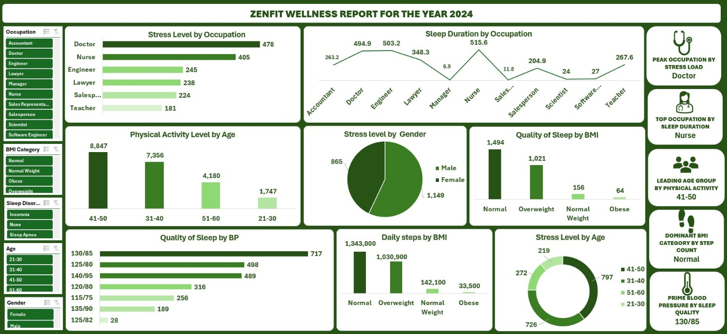

RECOMMENDATIONS AND OBSERVATIONS
Observations:
1. Doctors have the highest stress level at 408, while Teachers have the lowest stress level at 181.
2. Nurses accumulate the most sleep duration 515.6 hours, while managers have the least sleep duration at 6.9 hours.
3. The 41-50 age group leads in physical activity levels (8,847), while the 21-30 age group has the lowest (1,747).
4. Males have a higher total stress level (1,149) compared to females (865).
5. Individuals with a normal BMI category have the highest quality of sleep (1,494), followed by overweight individuals (1,021).
6. Age group of 41-50 has the highest stress level of 797 and age group of 21-30 have the lowest stress level of 219.
7. Doctors and nurses have the highest stress level at 478 and 405, while teachers have the lowest at 181.
8. Blood pressure range 130/85 have the highest quality of sleep at 717, while blood pressure range 125/82 has the lowest quality of sleep at 28.
9. 41-50 age group has the highest physical activity level at 8,847, and 21-30 age group at 1,747.
10. Normal BMI has the highest daily steps at 1,343,00, while the obese category has the lowest at 33,500.

Recommendations:
1. I suggest developing stress management programs, like yoga, specifically for Doctors and Nurses, who show the highest stress levels, to improve their mental well-being.
2. Create educational campaigns or sleep tracking tools for salespersons, who have the lowest sleep duration, to encourage better sleep habits and reduce potential health risks.
3. Launch fitness challenges for the 21-30 age group, who have the lowest physical activity levels, to boost their engagement in exercise.
4. Given that males report higher stress level, offer a tailored stress-relief solutions for men, such as fitness boot camps, while providing women with mindfulness-focused programs.
5. Develop targeted wellness programs for those in the Obese BMI category, who report the lowest sleep quality, incorporating sleep aponia screenings and weight management plans to improve sleep outcomes.
6. Introduce step-count challenges or walking groups for Overweight and obese individuals to bridge the gap with the Normal BMI group, promoting cardiovascular health.
7. Offer sleep improvement resources (e.g., relaxation techniques, sleep tracking) for individuals with 125/82 blood pressure, who have the lowest sleep quality, to enhance their overall health.
8. Create midlife wellness programs (e.g., fitness classes) for the 41-50 age group, who experience the highest stress levels, to support work life balance during this life stage.

CONCLUSION
Key learning:
- Doctors and Nurses experience the highest stress levels, indicating the need for targeted mental health programs.
- Managers have the shortest sleep duration, highlighting potential work-life balance issues.
- The 41-50 age group is the most physically active, suggesting increased health awareness with age.
- Individuals with normal BMI report better sleep quality and higher step counts, emphasizing the importance if maintaining a healthy weight.

Limitations:
- The dataset does not capture all professions and health related variables like mental health conditions.

Future Research:
- Analysing the impact of wellness programs, fitness initiatives, or flexible work policies on stress reduction.

